

Topic test 2
Name: __________________________________

Chapter 5: Undirected graphs

• Time allowed: 45 minutes
• CAS calculators may be used.
• Part A: 6 multiple-choice questions (6 marks)
• Part B: 6 short-answer questions (16 marks)
• Part C: 2 analysis questions (11 marks)
Part A
Multiple-choice questions
6 multiple-choice questions
1 mark each: 6 marks
Circle the correct answer.
1 The sum of degrees in the following graph is:
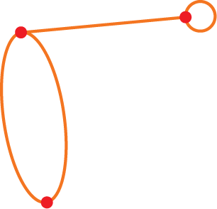
A 4
B 5
C 3
D 8
E 6

[1 mark]

2 Which of the following adjacency matrices would be used to represent the graph below?
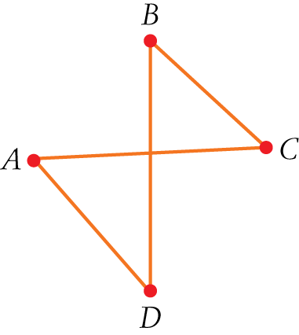
A 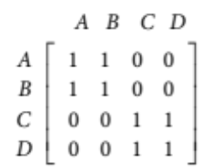
B 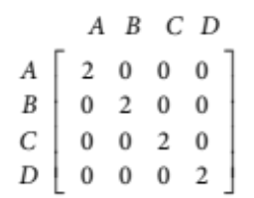
C 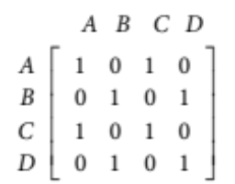
D 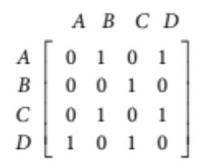
E 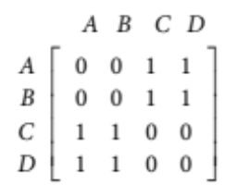

[1 mark]
3 A connected planar graph has 12 vertices and 6 faces. A number of edges are removed to leave a connected planar graph with 12 vertices and 2 faces. How many edges were removed?
A 6
B 16
C 4
D 10
E 8

[1 mark]
4 A complete graph contains 28 edges. How many vertices does the graph contain?
A 7
B 27
C 8
D 28
E 14

[1 mark]
5 Which one of the following graphs is Eulerian?
A 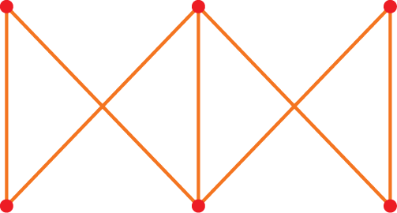 B 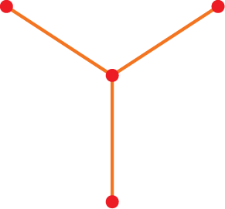 C 
D 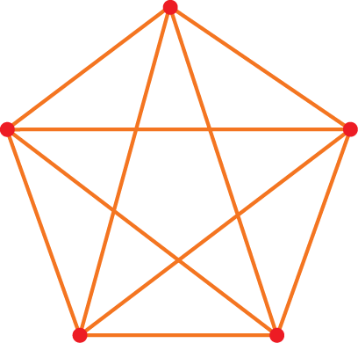 E 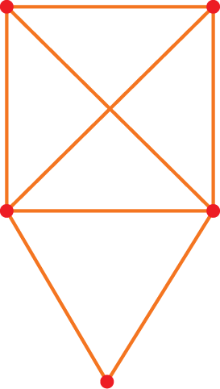

[1 mark]
6 A salesman is selling computer software to local businesses. He will visit every business once only and not return to the business at which he started.
This situation can best be represented by:
A A Eulerian graph
B A semi-Eulerian graph
C A Hamiltonian path
D A Hamiltonian cycle
E A minimum spanning tree

[1 mark]

Part B
Short-answer questions
6 short-answer questions
16 marks
Show your working where appropriate.
1 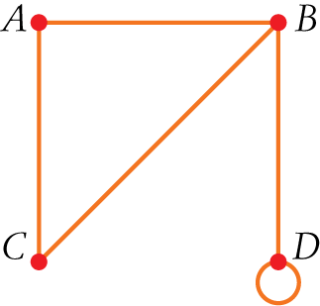
The following matrix represents the graph above. The matrix is missing two values k and m. State the values of k and m.
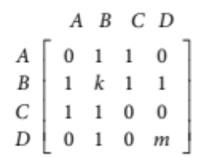
k = m =
[2 marks]
2 Two chess teams are playing each other in a grand final. Each team has four players and each player on the team plays each player on the other team once. Unfortunately, one player from one team received an injury and could not play.
a Represent the games played using a bipartite graph with the eight players as the vertices of the graph and the edges the games played.

b How many games were played?

[3 marks]

3 Redraw this graph as a planar graph:
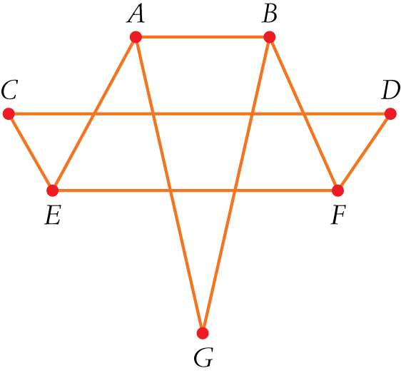

[2 marks]
4 Which edge/s need to be added or removed to make the following graph semi-Eulerian?
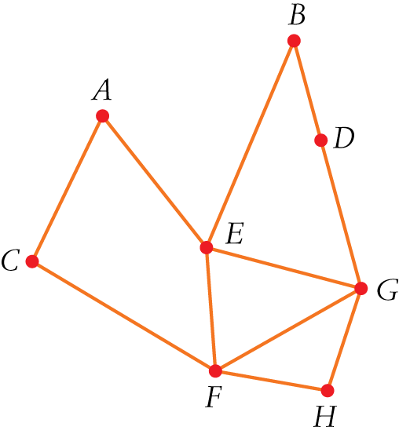

[2 marks]

5 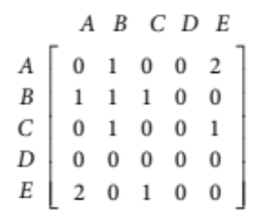
For the above matrix:
a What do all the zeros in row D indicate?

b What does the ‘1’ at the intersection of row B column B indicate?

c What does the ‘2’ in the matrix represent?

d Draw the graph that corresponds to this matrix.

[4 marks]

6 For the following graph:
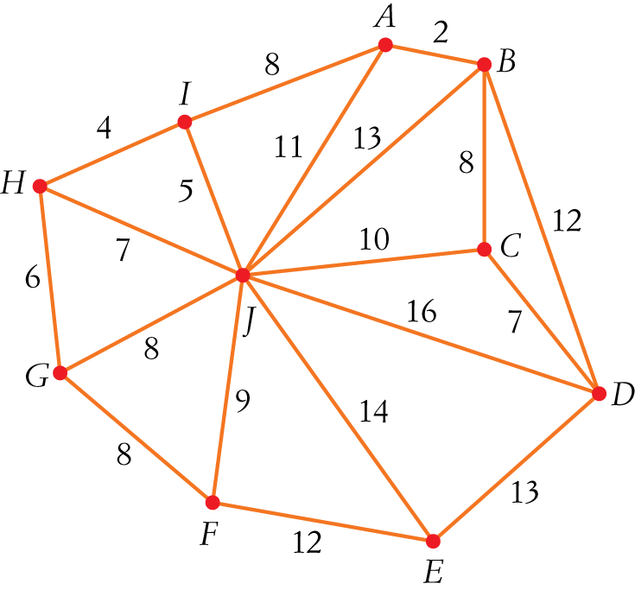
a Use Prim’s algorithm to find the minimum spanning tree.

b What is the total weight of this minimum spanning tree?

[3 marks]

Part C
Analysis questions
2 analysis questions
11 marks
Show your working where appropriate.
1 A park has 10 large trees. The trees are denoted as vertices A to J on the following graph. Walking paths between the trees are indicated by the edges, with the numbers on the edges indicating the lengths of the paths in metres.
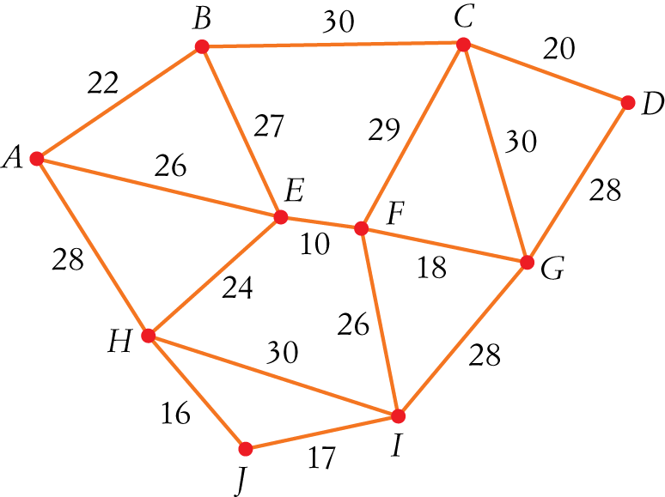
a Determine the sum of the degrees of the vertices in this network.

b Danielle wishes to walk through the park on a route that will take her along each of the paths between the trees.
i State a vertex at which Danielle should begin her walk.

ii Determine the total distance Danielle will walk, to the nearest metre.

c Danielle’s friend Hayley takes the following route: A-H-J-I-F-G-D-C-B-E-A.
i What is this route an example of?

ii Determine the total distance Hayley will walk, to the nearest metre.

[5 marks]
2 The map below shows the roads that connect the towns of Armein, Bufort and Castleton. The towns and major intersections (indicated by open circles) form the vertices of this network of roads.
Labels on the roads indicate their names and lengths in kilometres. For instance, (D, 4) indicates Road D is
8 km long.
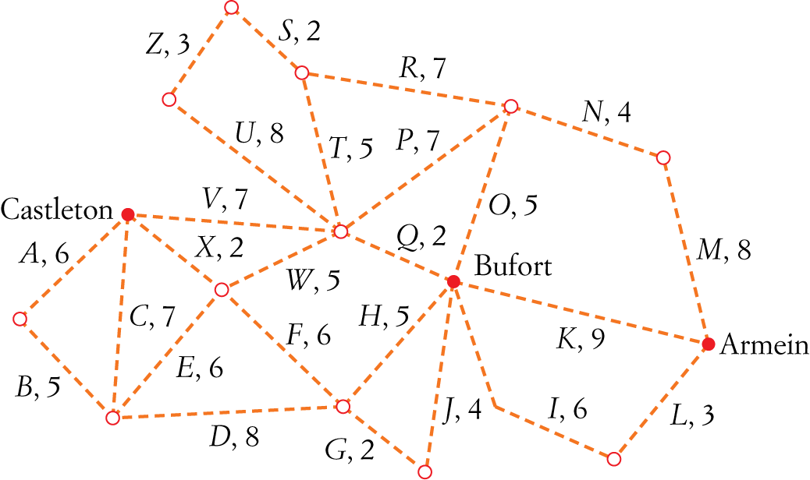
The Champs Running Club conducts a race beginning at Armein with checkpoints at every vertex in the graph. The race covers the full length of every road on the network in any order or direction chosen by the runners. A runner may pass through each checkpoint more than once, but must travel along each road exactly once.
a One competitor claims that this cannot be done. By referring to the degrees of the vertices in this network of roads, explain why it is possible to travel every road once only when running according to the club’s rules.

b Under the club’s rules for the race, the finish line must be at the intersection of which three roads?

c One competitor begins his race along the roads A-B-C-X-W-U-Y in that order.
To continue the race, along which road should this competitor travel next?
Justify your answer.

d For the following year, the club wants to start at Armein and finish at Castleton over the shortest route that still requires runners to run the full length of every road in the graph.
The rules will be modified to allow runners to travel twice along roads if required.
Which road/s will be travelled twice to meet the race requirements in the shortest distance?

[6 marks]
[Total marks: 33]

Answers
Part A – Multiple-choice questions [1 mark each]
1 Number of edges = 4
Degree sum = 2 × number of edges = 8
∴ D
2 E = {AC, AD, BD, BC}
A ‘1’ is to be placed at the intersection of the edges.
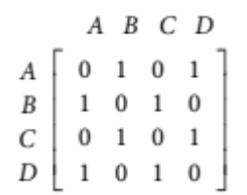
∴ E
3 Original graph: V = 12, F = 6
Using Euler’s formula:
V  E + F = 2
12  E + 6 = 2
E = 16
New graph: V = 12, F = 2
Using Euler’s formula:
V  E + F = 2
12  E + 2 = 2
E = 10
16  10 = 6
6 edges were removed.
∴ A
4 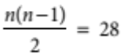
n(n  1) = 56
n²  n  56 = 0
(n  8)(n + 7) = 0
n = 8
n ≠ 7
The number of vertices is 8.
∴ C

5 For a graph to be Eulerian all vertices must be of even degree.
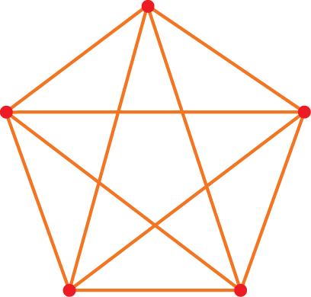
The above graph is the only option that has all vertices of even degree.
∴ D
6 The salesman must visit every business (represented by vertices on a graph) only once and not return to his starting point. This is an example of a Hamiltonian path.
∴ C
Part B – Short-answer questions
1 There is no loop at B; therefore, k = 0.
There is a loop at D; therefore, m = 1. [2 marks]
2 a One player is not connected.
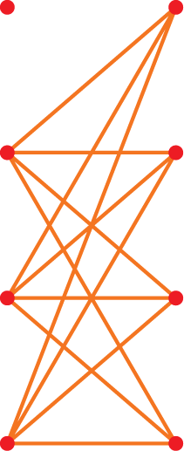
[2 marks]
b There are 12 edges; therefore, 12 games were played. [1 mark]
3 The graph must be redrawn so that no edges cross.
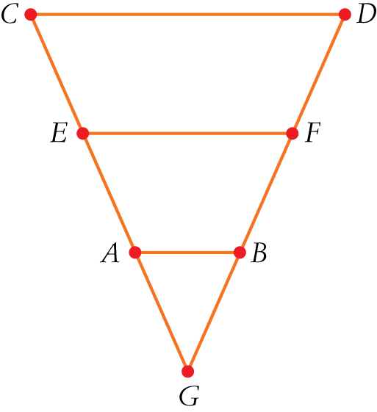
[2 marks]

4 An edge needs to be added or removed to enable two vertices to have odd degrees. [2 marks]
There are many possible answers. Adding AB will make the degree of A and B odd, hence making the graph semi-Eulerian.
5 a D is an isolated vertex. [1 mark]
b There is a loop at B. [1 mark]
c Two edges connect A and E. [1 mark]
d 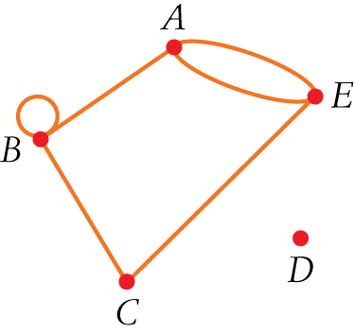
[1 mark]
6 a 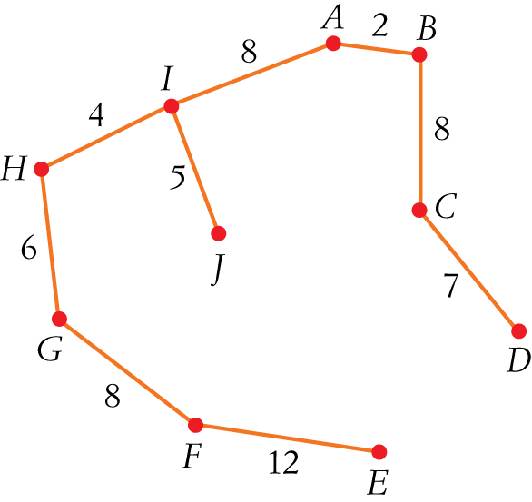
[2 marks]
b 7 + 8 + 2 + 8 + 5 + 4 + 6 + 8 + 12 = 60 [1 mark]
Part C – Analysis questions
- a deg A = 3
deg B = 3
deg C = 4
deg D = 2
deg E = 4
deg F = 4
deg G = 4
deg H = 4
deg I = 4
deg J = 2 [1 mark]
b i The route is an open trail; therefore, start at A or B, as they have odd degrees. [1 mark]
ii Adding all the edges = 409 m [1 mark]
c i Hamiltonian cycle [1 mark]
ii Adding all the edges covered = 236 m [1 mark]

2 a Not every vertex is of even degree. [2 marks]
b R, S and T, as they all connect a vertex that has an odd degree. [1 mark]
c V, as all the other roads have already been travelled on. [2 marks]
d Must still finish travelling on all the edges at a vertex with an odd degree; therefore, to continue on to Castleton in the shortest distance you must travel along T-Q-K or T-Q-I-L. [1 mark]

Topic test 2

